Nepal College of Information Technology
Unit Test
Spring 2011
Program : BE IT Time : 2 hrs
Semester : (II) FM : 70
Subject : Electronic Devices PM : 35
- Candidates are requested to give their answer as far as practicable in their own words.
- The figure in the margin indicates the full marks
- Attempt ALL question
1.a) | Is diode a linear device? Explain. Find the piecewise linear model of a Si diode having η = 1.6 and I_{s} = 10⁻¹¹ A when it is working in the vicinity of 1 mA at a working temperature of 30 °C. | 2+5
b) | Explain the working principle of a pn junction diode under forward and reverse bias condition with appropriate figures. | 8
2.a) | Differentiate between transition region capacitance and depletion region capacitance. | 7
b) | Find the range of voltage source V_{s} for which the following circuit maintains a constant voltage across the load resistor R_{L}. (Given I_{ZK} = 1 mA, P_{ZMAX} = 100 mW)  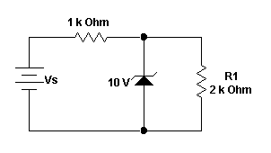 | 8
3.a) | Describe the working principle of an npn transistor. | 7
b)  4.a)  b)  5.  a)  b)  c)  d) | Explain the input and output characteristic cures of an npn BJT working in common emitter configuration.  Draw the circuit diagram of a bridge full wave rectifier. Compare the efficiency of a have wave rectifier and a full wave rectifier.  Draw the output waveforms for the following: (Assume sinusoidal input)  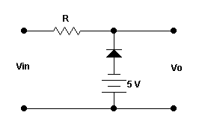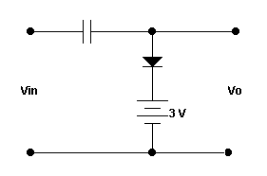  i) (ii)  Write short notes on: (Any two)  Tunnel diode  Varactor diode  Difference between Zener and Avalanche breakdown  Zener diode as a voltage regulator | 8  3+4  4+4  5*2

